DYNAMICS SCHOOL OF PERFORMING ARTS

COMP SQUAD CODE OF CONDUCT

IMPORTANT INFORMATION
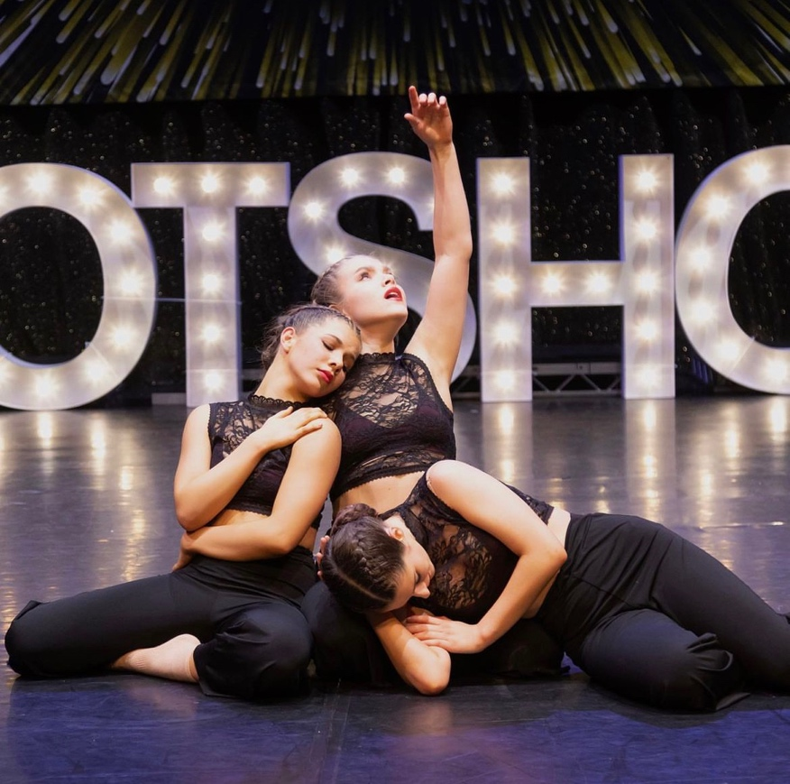

Our aim at DSOPA is to ensure that all students experience dance in a fun, friendly, positive and safe environment. In order to achieve this, please take note of our following comp squad guidelines.
Any student/parent unable to comply with the rules provided by the DSPOA may be asked to withdraw from the squad(s).

PAGE 1- STUDENT CODE OF CONDUCT
PAGE 2- PARENT CODE OF CONDUCT/ 3 STRIKE POLICY
PAGE 3- COMPETITION INFORMATION
PAGE 4- PRIVATE INFORMATION/PRICING
PAGE 5- CLASS INFORMATION
PAGE 6- COSTUME INFORMATION

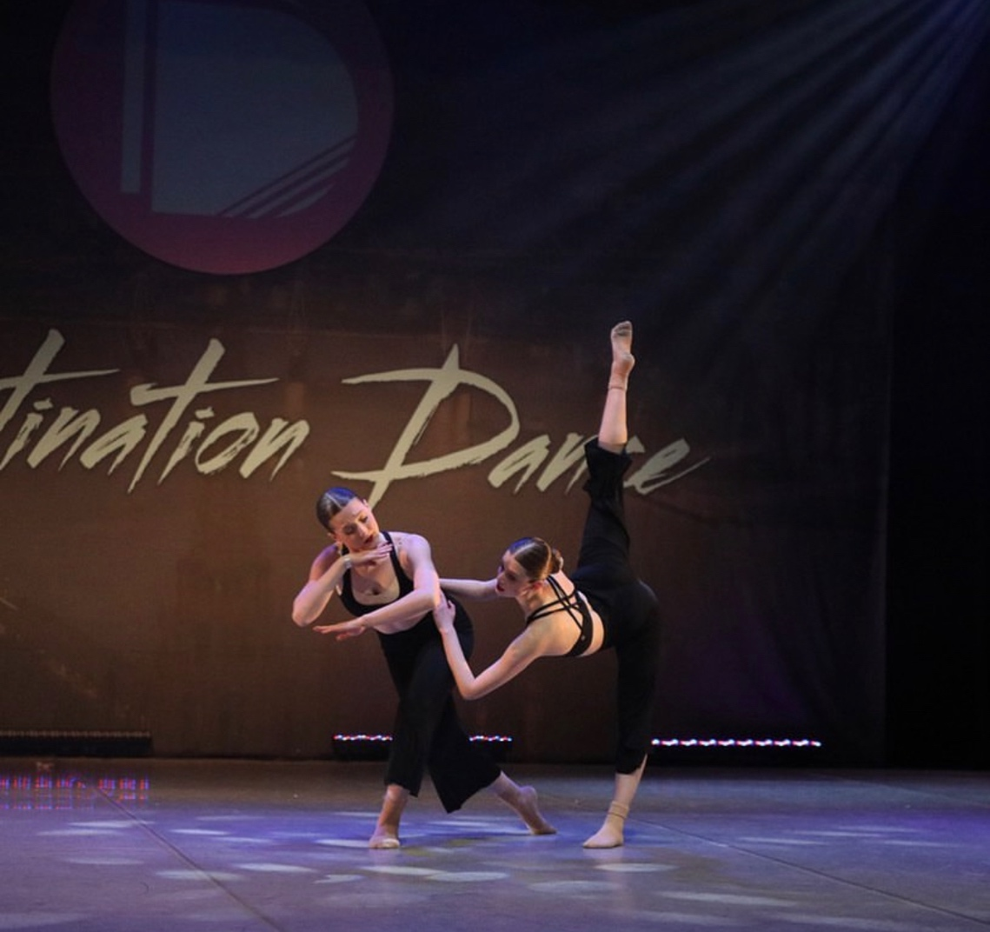

COMP SQUAD PERFORMERS Code of Conduct
We expect all performers to:
- Attend all rehearsals- Remember we are a team! It is only fair to your teachers and your teammates that we attend all rehearsals. Poor attendance to rehearsals may affect your position in the squads.
- Attend all competitions- All squads will receive the dates prior to the season starting.
- Complete the competition season
- Attend the rotary carnival festival (August bank holiday weekend)
- Respect each other & our faculty. This includes listening when the teacher is speaking, not talking back, not talking during lessons unless asking a question and applying corrections/trying new suggestions positively, without hesitation.
- Support each other. Encourage your fellow class members and be positive. Bullying in any form will not be tolerated. Also, do not correct other members of your class. You are not the teacher.
- Be on time. The class starts at the time of the class this isn’t time for you to be strolling into lesson. In fact, you should always be early. Arriving late to class is disruptive and extremely disrespectful to your teacher and your other team mates.
- Be prepared. There are no excuses for coming to comp class unprepared.
- Consistently try your best.
- Do not compare yourself to others journey’s- You must remember we are all on our own path!
- Attend class every week unless with good reason. Regular class attendance is key to improving yourself as a dancer. For every class you miss, you effectively put yourself back a week in terms of training. Over time this can have a big impact on your overall standard.
- Wear proper dress code- Hair must be tied back, no phones, no socks, no jewellery, no baggy clothing unless street/commercial.

USE OF CHOREOGRAPHY:
- The choreographer own’s the rights to each of their pieces. Use of the choreography without their permission is forbidden.

Parents code of conduct

- Aggressive, abusive or anti-social behaviour is not tolerated from parents or students in any part of the premises or at any Please conduct yourselves in an appropriate manner and respect the DSOPA staff, all visitors and policies always. All incidents will be reported and investigated accordingly.
- Drop off/collection - Parents and guardians are asked to drop off students directly before the start of their class and to supervise them until the class time and you MUST pick them up from the door. Unless advised parents are not allowed to watch rehearsals/privates due to our safeguarding policy.
- Any incident reported to DSOPA may result in suspension with the possibility of being fully withdrawn from the DSOPA. Serious incidents may result in immediate withdrawal from the DSOPA.
- Pay all competition fees in advance.
- Respect the ethos, vision and values of DSOPA
- Respect our staff and their decisions surrounding your child & competitions. Our faculty have years of experience and always have the children’s best interest at heart.
- Seek a peaceful and reasonable solution to all issues.
DYNAMICS SCHOOL OF PERFORMING ARTS 3 STRIKE POLICY SYSTEM
Disruptive or threatening behaviour of any kind is unacceptable at DSOPA and will not be tolerated.

DSOPA now operates a new strict three strikes policy.
1. Any student/parent, failing to meet our behaviour standards will receive a verbal warning.
2. If the behaviour continues, a second warning will be issued to the student and their parents/carers and recorded by DSOPA.
3. If the written warning or continued verbal warnings have no effect, the student/parent will be suspended or expelled from DSOPA at the discretion of the principle.

Student Signature:________________________Date:_____________
Parent/Guardian Signature:________________________Date:_____________
DSOPA:________________________Date:_____________

COMPETITION IMPORTANT INFORMATION

Please find here useful FAQ’s surrounding our competition squads!

Why should I join a competitive dance squad?

At DSOPA our competitive dancers get to perform multiple times a year. This means they are not only being given the opportunity to showcase their progress, achievements, and skills on a regular basis, but they are developing a baseline of experience for dancing on stage. These competitions are judged by some of the UK’s top leading choreographers/ principles of prestigious dance colleges. Also, by competing at these events students are offered the chance to compete for scholarships to some incredible summer schools, foundation courses and even college courses!

At a competition what time does my child need to arrive?

An hour and a half before they are due to go on stage for their first dance.

What does my child need to wear when they arrive at a competition?

Dynamics uniform unless advised otherwise.

What should I pack in my child’s bag?

Costumes, hair and make-up bag, food (no nuts, fizzy drinks, sweets), entertainment (book, tablet, phone if they are older, games), comfy clothes.

How do I store costumes?

In a costume bag with all costumes labelled with their name.

What underwear is best for my child to wear?

Nude underwear or a nude leotard.

Hair and make up for the competition?

Hair in a middle parting low bun (unless advised otherwise). Please see picture below for make-up example.

PRIVATE INFORMATION

If your child has solo(s), duo(s), trio(s), small group select numbers please see below on important information and FAQ’s surrounding privates and what to do.

How do I know what numbers my child is doing?

When a new season begins a spreadsheet will be released with each number and group which you will have access to.

How do I book privates?

You will all be added to a chat in which a teacher will organise privates each week in line with your child’s availability,

How many privates will I need to book per number?

It normally takes a teacher x4 30 minute privates for the child/children to learn the routine although it does depend on the student. After that time the student must be rehearsing this in their own time and will need additional privates to clean their routine.

How much does it cost?

SOLO 30 MINUTE PRIVATE -

DUO 30 MINUTE PRIVATE-

TRIO 30 MINUTE PRIVATE -

SMALL GROUP PRIVATE-

Where are the privates and what days can we book?

Privates are available all week MON-SAT, and are located mainly in East Worthing and on Saturday’s it would be Shoreham By Sea.

Can we record our session?

You can record what you have learnt after every session, and it is highly important you do so.

CLASS INFORMATION: WHAT CLASSES SHOULD MY CHILD BE DOING IF THEY ARE IN COMP SQUAD(S)

TOTS TEAM:

COMP SQUAD REHEARSALS: 2 HOURS XPER WEEK
DANCE CLASS: X1 HOUR PER WEEK
ACRO OR STREETDANCE: X1 HOUR PER WEEK
BALLET OR TECHNIQUE CLASS: 30/45MINUTES PER WEEK

JUNIOR AND TEEN TEAM:

COMP SQUAD REHARSALS: X2 HOURS PER WEEK
DANCE: X1 HOUR PER WEEK
ACRO: X1.5 HOURS PER WEEK
BALLET OR TECHNIQUE CLASS: 30/45MINUTES PER WEEK
COMMERCIAL OR CONTEMPORARY: X1 HOUR PER WEEK

SENIOR TEAM:

COMP REHEARSAL: X2.5 HOURS PER WEEK
DANCE: X1 HOUR PER WEEK
BALLET: X1.5 HOURS PER WEEK
BALLET TECH: X30 MINUTES PER WEEK
ACRO: X1.5 HOURS PER WEEK
TECHNIQUE: X45MINUTES PER WEEK
COMMERCIAL OR CONTEMPORARY: X1 HOUR PER WEEK
STRETCH AND CONDITION OR TAP: X30 MINS PER WEEK

ACRO SQUAD:

COMP REHEARSAL : 45MINS PER WEEK
CLASS: 2.5 HOURS PER WEEK
RECOMMENDED: CONTEMPORARY OR COMMERCIAL

STREET SQUADS/ MT SQUADS

MUST ATTEND THE CLASSES PER WEEK AND EXTRA REHEARSALS

COSTUME INFORMATION

PLEASE SEE BELOW FAQ’S SURROUNDING COSTUMES & PRICINGS.

How do we choose costumes?

Normally the teacher has the final say in their costume choice for the piece. However, we will always discuss with the parent and student before solidifying those choices and are always open to your own suggestions.

How much do they cost?

Costumes range from £10-£60, you are more than welcome to look into bespoke costumes for solos but these are pricier. For example companies like JODRESSMAKER, dancewearbyella.

Can we buy second hand?

Second hand is an option as we will resell lots of our costumes, we have within DSOPA already.

How do we order costumes/buy them?

DSOPA will order them and you will be invoiced for the costumes.

How many costumes are we likely to need?

It will depend on how many numbers the students are in. It is normally x1 per number, including your base nude underwear you must wear at all times under it.

How do we look after costumes?

It is so important that we take care of our own costumes. In recent competitions we have had too many items of costumes missing. Please make sure you are storing your costumes in a labelled costume bag, and even additional labelled bags for your props and shoes. If you lose your costumes/props you must replace these ASAP.

